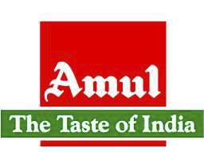 INTRODUCTION

Amul (Anand Milk Union Limited), formed in 1946, is a dairy cooperative movement in India.

It is a brand name managed by an apex cooperative organisation, Gujarat Co-operative Milk Marketing Federation Ltd. (GCMMF), which today is jointly owned by some 2.6 million milk producers in Gujarat, India.

AMUL is based in Anand, Gujarat and has been a sterling example of a co-operative organization's success in the long term.

It is one of the best examples of co-operative achievement in the developing economy.

Amul has spurred the White Revolution of India, which has made India the largest producer of milk and milk products in the world.

It is also the world's biggest vegetarian cheese brand.

Amul is the largest food brand in India and world's Largest Pouched Milk Brand with an annual turnover of US $1050 million (2006-07).

Currently Amul has 2.6 million producer members with milk collection average of 10.16 million litres per day.

The brand name Amul means “AMULYA”. This word derived from the Sanskrit word “AMULYA” which means “PRICELESS”. A quality control expert in Anand had suggested the brand name “AMUL”.

Amul products have been in use in millions of homes since 1946. Amul Butter, Amul Milk   
Powder, Amul Ghee, Amul spray, Amul Cheese, Amul Chocolates, Amul Shrikhand, Amul   
Ice cream, Nutramul, Amul Milk and Amulya have made Amul a leading food brand in India.

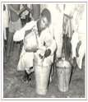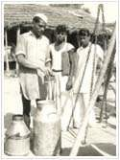

HISTORY

The Amul revolution was started as awareness among the farmers. It grew and matured into a protest movement that was channelled towards economic prosperity.

The Kaira District Co-operative Milk Producers' Union Limited (KDCMPUL) began pasteurizing milk for the Bombay Milk Scheme in June 1948.

By the end of 1948, more than 400 farmers joined in more Village Society, and the quantity of milk handled by one Union increased from 250 to 5,000 litres a day.

Meanwhile, Dr. Verghese Kurien, fed up being at the government creamery in Anand,   
Gujarat, which held no challenge, volunteered to help Shri Tribhovandas Patel, the Chairman   
of KDCMPUL, in setting up a processing plant. This marked the birth of AMUL in 1946.

The success of Amul was instrumental in launching the White Revolution that resulted in increased milk production in India. It is officially termed as Operation Flood by Amul. The breakthrough technology of spray-drying and processing buffalo milk, developed by Mr. H.M. Dalaya, was one of the key factors that contributed to the Revolution.

Over six decades ago the life of a farmer in Kaira was very much like that of farmers anywhere else in India. His income was derived almost entirely from seasonal crops. Many poor farmers faced starvation during off-seasons. Their income from milch buffaloes was undependable. The milk marketing system was controlled by contractors and middlemen. As milk is perishable, farmers were compelled to sell their milk for whatever they were offered. Often they had to sell cream and ghee at a throwaway price.

They were in general illiterate. But they could see that the system under

which contractors could buy their produce at a low price and arrange to sell   
it at huge profits was just not fair. This became more noticeable when the   
Government of Bombay started the Bombay Milk Scheme in 1945.   
Milk had to be transported 427 kilometres, from Anand to Bombay.

**INDUSTRY PROFILE**

**An Overview**

Industry is one of the major constituents of the comprehensive term ‘Business’   
which may be defined as the regular or current production or purchase and sales of   
goods undertaken with the main object of earning profit and acquiring wealth   
through the satisfaction of human wants, and in the terms of Economics, business   
may be described as a programmed of inputs (investment) and output (return)   
aiming at the maximization of output with lowest input. Industry as a part of   
business activity is concerned with the raising, producing, processing or fabricating   
products or services which may be used either by the final consumers or by other   
industrial units for further production.

Industry may, broadly, be classified into four types viz., (a) Extractive (b) Genetic

(c) Manufacturing and (d) Constructive industry. Historically, they may be   
categorized into (a) Primary or Natural industries, and (b) Factory industry. In the   
former are included (1) Hunting (2) Fishing (3) Animal husbandry (4) Forestry (5)   
Agriculture (6) Mining (7) and all other industries, which use, predominantly   
natural resources as the basis for their productivity activities and whose products   
are utilized mainly by the ultimate consumers. While the later covers those   
industries which undertakes, on massive scale, conversion of raw material into   
finished products by extensive use of plant and machinery metallurgical industries,   
engineering industries, textile industries, chemical and allied industries, food   
industries, generation and distribution of electricity, etc. In the process of   
industrialization, the primary industries get gradually and progressively submerged   
with the factory industries.

Dairy industry occupies an important place in animal husbandry. It embraces the   
production of milk, its preparation for sale as well as the manufacture of dairy   
products. The Central Statistical Organization, Department of Statistics.   
Government of India, have under the annual survey of industries, classified dairy   
industry under industries major group-20, Food Manufacturing Industries.

**DAIRY INDUSTRY IN INDIA**

Dairy industry plays a dynamic role in India's agro-based economy. Dairy is now a highly specialized field today that involves production, procurement, storage, processing and distribution of dairy products. The dairy industry involves processing raw milk into products such as consumer milk, butter, cheese, yogurt, condensed milk, skimmed milk powder and ice cream, using processes such as chilling, pasteurization, and homogenization.

India is the largest producer and consumer of milk in the world. The Indian dairy   
sector is characterized by a very large number of small herds. Production of milk   
from buffaloes exceeds that of cows, which are considered sacred by Hindus. India   
has an extensive government supported dairy cooperative structure. Milk from the   
small herds is collected by the cooperatives with centralized cooling facilities and   
transported to the end-users in urban centers. Most of the milk produced (over 80%)   
is distributed as liquid milk for home consumption or manufacturing of traditional   
products like ghee, paneer and mithais. From burfi to kulfi, from kalakhand to   
shrikhand, from yogurt to ice creams extend the delectable world of Indian milk   
delicacies. India surpassed the US in 1998 with a production of 92 million tonnes to   
become the largest milk producing country in the world. In 2006, India's milk   
production crossed 100 million tonnes, representing 15% of world milk production.   
From being milk impoverished nation to the top producer has been an astonishing   
success.

About 110,000 dairy cooperative village societies, involving 12 million farmer members had been organized by 2003-04 to supply milk to processing units and directly to consumers. Until the early 1990s, milk processing was reserved for the cooperative sector through licensing. As part of the domestic economic reforms and commitments to the WTO regulations, the Indian dairy sector was liberalized in a phased manner starting in 1991. The government removed all restrictions on setting up new milk processing capacity in March 2002

The dairy scene with an anticipated milk production of 127.9 million tonnes, an   
increase of around 5 per cent over the year 2010-11, India continued to be the largest milk producing nation in 2011-12.

This accounted for about 17 per cent of   
world milk production. More people in India now consume milk. The 66th Round   
of National Sample Survey Organisation data on consumer expenditure showed that   
while 85 per cent of the population in urban areas consumes milk in their homes, it   
is 76 per cent in rural areas. The dairy cooperatives collected 10.5 million tonnes of   
milk, an increase of around 10 per cent as compared to 2010-11. Milk marketing by   
the cooperatives stood at 8.6 million tonnes, an increase of around 4 per cent   
compared to the previous year. The co-operatives paid a higher procurement price   
to milk producers to offset the high input cost for milk production. At the instance   
of Government of India, NDDB imported 50,000 tonnes of milk powder and 6,000   
tonnes of butter under the Tariff Rate Quota (TRQ) to ensure availability of liquid   
milk during the lean season and to meet the requirements of cooperatives and city   
dairies

The credit of the huge success behind the dairy industry must be attributed in great   
measure to Operation Flood which was a rural development programme started by   
India's National Dairy Development Board (NDDB) in 1970. One of the largest of   
its kind, the programme objective was to create a nationwide milk grid. It resulted   
in making India one of the largest producers of milk and milk products. The success   
behind Operation Flood was the Gujarat-based Amul (Anand Milk Union Limited)   
which in turn became a mega company based on the cooperative approach. Dr.   
Varghese Kurien gave the professional management skills and necessary thrust to   
the cooperatives and is considered as the architect of India's White Revolution. The   
Amul model has helped India to emerge as the largest milk producer in the world.   
More than 15 million milk producers pour their milk in 1,44,500 dairy cooperative   
societies across the country. Their milk is processed in 184 District Co-operative   
Unions and marketed by 22 State Marketing Federations, ensuring a better life for   
millions.

Milk production is primarily a supplementary occupation for small landholders or   
landless labourers. There are no official counts of dairy farms and estimates vary   
widely. Some estimates indicate that approximately 70 million rural households are engaged in milk production.

The average herd size is two milking animals and average daily milk production per herd is about four litres. The average yield per cattle is very low in the country, because cattle are fed primarily on dried straw or residues from crop production. Dairying is practiced throughout India, but concentrated in the north-western states where the climate is temperate. The milk surplus states in India are Uttar Pradesh, Punjab, Haryana, Rajasthan, Gujarat, Maharashtra, Andhra Pradesh, Karnataka and Tamil Nadu. The top 6 states, viz., Uttar Pradesh, Punjab, Madhya Pradesh, Rajasthan, Tamil Nadu and Gujarat together account for 58% of the national production.

Dairy sector, mainly an offshoot of agriculture sector in India, has taken shape of an   
industry in a big way today. Intimately interwoven with the socio-economic fabric   
of rural people in India, dairying has played a crucial role in providing nutritional   
security to the millions of households. It has also strengthened our economy all   
along by supplementing family incomes and generating gainful employment in the   
rural sector.

Indian dairy industry of late has become the major growth area and goes far beyond   
being an important agri-business sector of the national economy. Besides being the   
largest milk producing country with 5 per cent annual increase in milk production,   
India has a large market of dairy products due to the constantly increasing demand   
for variety of milk products in the urban as well as rural sectors. The rising demand   
for value added milk products at the national level and opening of the markets at   
the international level under the changing global scenario and WTO have opened   
up new opportunities and threats alike for the Indian dairy industry

Our country is the world leader in the milk production thanks to the maximum   
cattle heads it has, and farmers and co-operative societies. Main aim of the Indian   
dairy industry is only to better manage the national resources to the highest milk   
producer in the entire globe - India boasts of that status. India is otherwise known   
as the ‘Oyster’ of the global dairy industry, with opportunities galore to the   
entrepreneurs globally. Anyone might want to capitalize on the largest and fastest   
growing milk and milk products' market. The dairy industry in India has been witnessing rapid growth.

The liberalized economy provides more opportunities for   
MNCs and foreign investors to release the full potential of this industry. The   
enhance milk production and upgrade milk processing using innovative   
technologies.

The growth of the Indian dairy section has been spectacular during the past three decades. But a sector growth depends heavily on the country’s trade policy and especially so in the changing environment after the setting up the world trade organization (WTO).

The Indian dairy industry is not only a vital producer of an essential food item but it   
also is one of the largest employers in the country in both the rural sector as the   
semi-urban and urban regions. The Indian dairy has called for continuous price   
monitoring of dairy products of both the international as well as national level in   
order to curb dumping.

As India is the largest milk producing country in the world, industry expert says that the adverse impact of the recent policies going to have a far reaching consequence on the economy as a whole.

Overall, the Indian dairy sector is experiencing an upheaval with new product launches, repositioning of brands and entry of newer players. This will also prompt several global players to enter the Indian market. The growth of disposable incomes, change in family structures, more women joining the work force and focus on healthy-nutritious and quality products are likely to result in demand for a shift towards dairy products that are not just functional and convenient but also meet the consumers' aspirational needs.

**COMPANY PROFILE**

EXTRA ORDINARY STORY OF AMUL

Every day Amul collects 447,000 litres of milk from 2.12 million farmers   
(many illiterate), converts the milk into branded, packaged products, and delivers goods   
worth Rs 6 crore (Rs 60 million) to over 500,000 retail outlets across the country. Its supply   
chain is easily one of the most complicated in the world. If we are visit to any Amul or   
Gujarat Cooperative Milk Marketing Federation (GCMMF) office a photograph of Mahatma   
Gandhi will be missing but we can certainly see one particular photograph showing a long   
line of Gujarati women waiting patiently for a union truck to come and collect the milk they   
have brought in shining brass matkas. This makes the farmers or the member of the   
organization of the organization how to prevent the milk from souring. Hence, Amul takes   
various initiatives to make the farmer or the producer understand how to provide service to   
the consumers with the only resource available with them i.e. milk a perishable one. The   
prominent display of picture states the message”

NEVER FORGET YOUR CUSTOMER. IF YOU DON’T SUCCESS IN CERTAIN”

At the time Amul was formed, consumers had limited purchasing power, and   
modest consumption levels of milk and other dairy products. Being a co-operative   
organization Amul adopted a low-cost price strategy to make its products affordable and   
attractive to consumers by guaranteeing them value for money. Amul also introduced higher   
value products. Beginning with liquid milk, Amul enhanced the product mix through the   
progressive addition of higher value products while maintaining the desired growth in   
existing products.

The Taste of India - these four words are more than what the common man may think   
of these - a mere slogan. Advertising people call this corporate positioning. But jargon   
apart these four words lend meaning to Amul's never ending crusade; they reinforce   
Amul's commitme nt of taking quality food products right down to the rural man,   
products, the common man otherwise would have never afforded. It was Amul that first   
made chocolate affordable to the 'aam admi', then followe d the same with Ice Cream,   
pizza and a range of value added products. Who would have thought that a tailor in   
Azamgarh or a traveling salesman in Barabanki, UP would be digging into a cup of   
Amul Ice Cream on a hot day.



THE STORY OF - AMUL BUTTER GIRL.





Eustace Fernandes, the creator of the Amul girl. Fernandes is best remembered as a   
cartoonist and an illustrator and was living a retired life for some time. The Amul as one   
moppet has featured in hoardings for almost 48 years, making it the longest running of in   
ad campaign ever in the world. The hoardings displayed one-liners that constituted as one   
a veritable commentary on contemporary political and social events, with each week after   
featuring a new theme.

The iconic Amul girl, which turns 43 this year, is all set to enter the Guinness Book of World as Records for being the longest running campaign in the world.

Way back in 1966, the Amul account was given to the advertising agency called Advertising in and Sales Promotion (ASP). The team of Sylvester da Cunha, Eustace Fernandes, Usha Katrak and Marie Pinto worked on the Amul account at that point of time. The ad became a rage with tagline 'Utterly butterly delicious Amul' - and the rest, they say, is history.

Fernandes worked on the Amul account for three years till 1969 and then the team of talent such   
Usha Katrak, K Kurian, Eustace Fernandes and Radha started Radeus Advertising in 1974.   
As a matter of fact, the word Radeus originated from the first three letters of Radha and Eustace.   
Edited from an article by Mini Varma published in The Asian Age on March 3, 1996.   
The moppet who put Amul on India's breakfast table 50 years after it was first launched, Amul's   
sale figures have jumped from 1000 tonnes a year in 1966 to over 25,000 tonnes a year in 1997.   
No other brand comes even close to it. All because a thumb-sized girl climbed to the hoardings   
and put a spell on the masses.

It all began in 1966 when Sylvester daCunha, then the managing director the advertising agency, ASP, clinched the account for Amul butter. The butter, which had been launched in 1945, in had a staid, boring image, primarily because the earlier advertising agency which was in charge for of the account preferred to stick to routine, corporate ads.

In India, food was something one couldn't afford to fool around with. It had been taken too be the seriously, for too long. Sylvester daCunha decided it was time for a change of image.   
The year Sylvester daCunha took over the account, the country saw the birth of a campaign whose charm has endured fickle public opinion, gimmickry and all else. The Amul girl who lends herself so completely to Amul butter, created as a rival to the Polson butter girl. This one was cute, as in village belle, clothed in a tantalising choli all but covering her upper regions.   
"Eustace Fernandez (the art director) I decided that we needed a girl who would worm her way into a housewife's heart. And why better than a little girl?" says Sylvester daCunha. And so on it came about that the famous Amul Moppet was born.

“We ran a couple of ads that created quite a furore," says Sylvester daCunha. "The Airlines is   
one really angered the authorities. They said if they didn't take down the ads they would stop   
supplying Amul butter on the plane. So ultimately we discontinued the ad," he says laughing.   
Then there was the time when the Amul girl was shown wearing the Gandhi cap. The high   
command came down heavy on that one. The Gandhi cap was a symbol of independence, they   
couldn't have anyone not taking that seriously. So despite their reluctance the hoardings were   
wiped clean. "Then there was an ad during the Ganpati festival which said, Ganpati Bappa   
More Ghya (Ganpati Bappa take more). The Shiv Sena people said that if we didn't do   
something about removing the ad they would come and destroy our office. It is surprising   
how vigilant the political forces are in this country. Even when the Enron ads (Enr On Or Off)   
were running, Rebecca Mark wrote to us saying how much she liked them."   
There were other instances too. Heroine Addiction, Amul's little joke on Hussain had the artist   
ringing the daCunhas up to request them for a blow up of the ad. "He said that he had seen the   
hoarding while passing through a small district in UP. He said he had asked his assistant to take a   
photograph of himself with the ad because he had found it so funny," says Rahul da Cunha in   
amused tones. Indians do have a sense of humour, afterall.

From the Sixties to the Nineties, the Amul ads have come a long way. While most people agree   
that the Amul ads were at their peak in the Eighties they still maintain that the Amul ads continue   
to tease a laughter out of them. Where does Amul's magic actually lie? Many believe that the love   
charm lies in the catchy lines. That we laugh because the humour is what anybody would enjoy.

RANGE OF PRODUCTS

Breadspreads

• Amul Butter.

• Amul Low Fat Bread Spread. • Amul Cooking Butter.

Cheese Range

• Amul Pasteurized Processed Cheddar Cheese.   
• Amul Processed Cheese Bread Spread.   
• Amul Pizza Mozarella Cheese.   
• Amul Shredded Pizza Cheese   
• Amul Emental Cheese.   
• Amul Gouda Cheese.

• Amul Malai Paneer (cottage cheese) • Utterly Delicious Pizza

Mithaee Range (Ethnic sweets)

• Amul shrikhand (Mango, Saffron, Pistachio, Cardamom) • Amul Amrakhand

• Amul Mithai Gulabjamun.

• Amul Mitahi Gulabjamun Mix. • Amul Mitai Kulfi Mix.   
• Avsar Ladoos

(ULTRA HIGH TEMPERATURE) UHT- Milk Range

• Amul Shakti 3% fat Milk

• Amul Taaza 1.5% fat Milk.   
• Amul Gold 4.5%Fat Milk.

• Amul Lite Slim & Trim Milk 0% Fat Milk. • Amul Shakti Toned Milk

• Amul Fresh Cream.

• Amul Snowcap Softy Mix

Pure Ghee

• Amul Pure Ghee.   
• Sagar Pure Ghee.   
• Amul Cow Ghee

Infant Milk Range

• Amul Infant Milk Formula 1 (0-6 months)

• Amul Infant Milk Formula 2 ( 6 months above) • Amul Spray Infant Milk Powder.

Milk Powders

• Amul Full Milk Cream Powder.   
• Amulya Dairy Whitener.   
• Sagar Skimmed Milk Powder.   
• Sagar Tea & Coffee Whitener.

Sweetened Condensed Milk

• Amul Mithaimate Sweetened Condensed Milk.

Fresh Milk

• Amul Taaza Tonned Milk 3% Fat.

• Amul Gold Full Cream Milk 6% Fat.

• Amul Shakti Standardised Milk 4.5% fat

• Amul Slim & Trim Double Toned Milk 1.5% fat • Amul Saathi Skimmed Milk 0% fat

• Amul Cow Milk

Curd Products

• Yogi Sweetened Flavoured Dahi (Dessert) • Amul Masti Dahi.

• Amul Masti Spiced Butter Milk • Amul Lassee

Amul Ice creams   
[Royal Treat Range](http://www.amul.com/icecream/royal.html)

• Butterscotch, Rajbhog, Malai Kulfi

[Nut-o-Mania Range](http://www.amul.com/icecream/nutomania.html)

• Kaju Draksh, Kesar Pista Royale, Fruit Bonanza, Roasted Almond

[Nature's Treat](http://www.amul.com/icecream/nature.html)

• Alphanso Mango, Fresh Litchi, Shahi Anjir, Fresh Strawberry, Black Currant, Santra   
 Mantra, Fresh Pineapple

Sundae Range

• Mango, Black Currant, Sundae Magic, Double Sundae Assorted Treat

Chocobar, Dollies, Frostik, Ice Candies, Tricone, Chococrunch, Megabite, Cassatta

Utterly Delicious

• Vanila, Strawberry, Chocolate, Chocochips, Cake Magic

Chocolate & Confectionery

• Amul Milk Chocolate

• Amul Fruit & nut Chocolate.

Brown Beverage

• Nutramul Malted Milk Food.

Milk Drink

• Amul Kool Flavoured Milk   
 Chocolate)

• Amul Kool Cafe

Health Beverage

Amul Shakti White Milk Food

(Mango, Strawberry, Saffron, Cardamom, Rose,

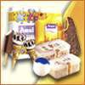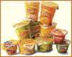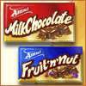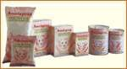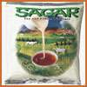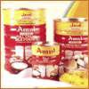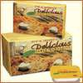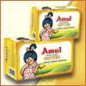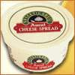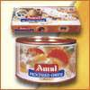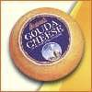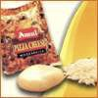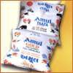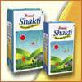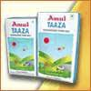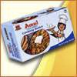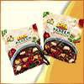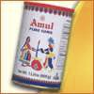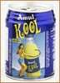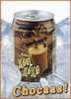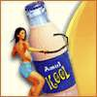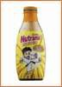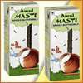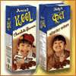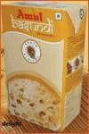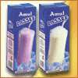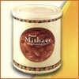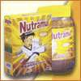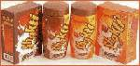

Amul — Business Model/Process Model

CONDENSED

GHEE

RAW

MILK

DRIED

SKIMMED

MILK

PACAKGED

MILK

Every day Amul Collects 7 million liters of milk from 2.6 million formers, converts the   
milk into branded, packed products and delivers goods to over 5,00,000 retail outlets across   
the country.

Its supply chain one of the most complicated in the world.

**REASON FOR SUCCESS**

Robust Supply Chain.

Low Cost Strategy .

Diverse product mix:- Amul Butter, Ghee, Milk Powde r, Cheese, Chocolate, Shrikhand, Ice Cream, Amulspray, Milk, Nutramul And Amulya.

Strong Distribution network

Technologhy And E-Initiatives

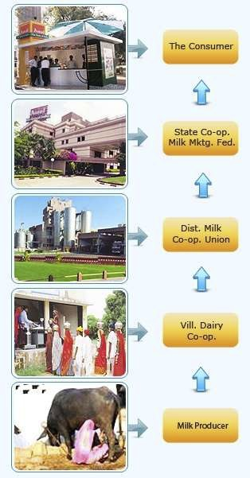

PROPER CHANNEL FOR AMUL PRODUCTS

“AMUL BRAND’’ is known for the Proper Working Strategy & Distribution Channel O f all   
its Products, Starting From the Milk Producers To the End Consumer. As it is known for the   
varied Range of Products the Distribution Channel is Properly Maintained in such a Manner   
that the End Consumer Comes up With a Satisfactory Smile After Trusting & Using “AMUL   
BRAND’’.

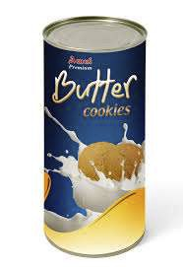

**‘AMUL BAKERY’ - A NEW INVENTION FROM AMUL BRAND TAKING A BOOST TOWARDS SUCCESS.**

AMUL BAKERY evolve a marketing philosophy that reflects the needs of the   
consumer. With products designed keeping both health and taste in mind, AMUL BAKERY   
appeals to both health conscious mothers and fun loving kids. The great tradition of taste and   
nutrition is consistent in every pack on the store shelves, even today. The value- for- money   
positioning allows people from all classes and age groups to enjoy amul bakery products to   
the fullest.

Amul, the country's biggest dairy brand, plans to expand its fledgling bakery products   
business and will soon build a plant that can produce 20 tonnes of cookies a day, a top   
official said.

"We are looking at a 40% annual growth for cookies, buns and bread that accounted for over

20 crore," Rahul Kumar, MD of the 2,800-crore Amul Dairy said that, "Unlike other brands which use butter flavour we are using 26% Amul butter in our cookies which consumers will like," he added.

The dairy cooperative has been selling cookies in chocolate, multigrain, butter and coconut varieties for two years in the Anand region catering to neighbouring markets of Ahmedabad and Vadodara in central Gujarat. It currently has a manufacturing capacity of 15-20 tonnes of cookies a month, which it says is not enough to meet demand.

The company will set up an automated plant at Mogar in Anand within a year, Kumar said. "We have received good response and feel that we can capitalise on distribution network of the federation that is experienced dealing with perishable products," he said.

Six months ago, Gujarat Cooperative Milk Marketing Federation (GCMMF) decided to brand and pack cookies attractively for the Anand market.

RS Sodhi, managing director at GCMMF, however, said the cooperative is in no hurry to take its non-dairy business national.

Despite becoming 20-crore portfolio for Amul Dairy, its diversification in cookies is yet to catch the attention of established players such as ‘Parle Products’ (maker of Hide & Seek and Milano), Britannia (Good Day) and ITC (Sunfeast).

A range of bakery items, including bread, bun and toast, is also on the menu of Kaira District Co-operative Milk Producers' Union, an important member of GCMMF. Currently, the union is conducting a pilot run for the products at its facility at Mogar.

According to sources, the union has lined up investments to the tune of Rs 12 crore for setting up a manufacturing facility with a capacity to produce of 1,00,000 bread packets a day, which may be enhanced later. It will manufacture biscuits and cakes subsequently.

"The biscuit and bakery items project will go on floors after one or two years," said Rahul Kumar , managing director, Kaira District Cooperative Milk Producers' Union.

Besides, GCMMF is there with two awesome milk shakes in three different tastes such as   
mango, strawberry and banana Which are Ruling the Tongue of Younsters in the Market.

"Awareness about natural taste and wellness is on the rise among people. After the response   
to flavoured milk, butter milk, lassi, Cool Cafe and Cool Coco, we are going to launch Amul   
milk shake in three different varieties with taste of fruits" said R S Sodhi, chief general   
manager, GCMMF.

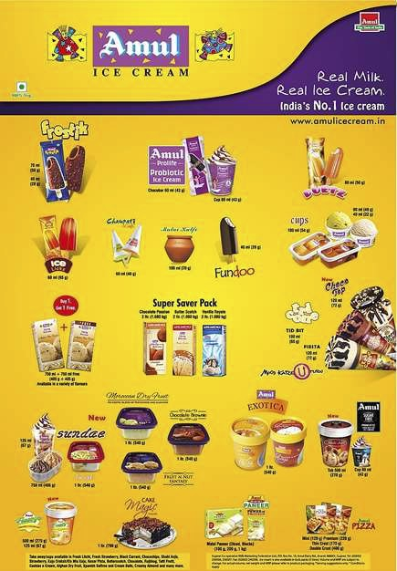

**TOP 4 PRODUCTS OF AMUL**

1. AMUL ICE CREAM

HISTORY OF AMUL ICE CREAM

Amul Ice Cream was launched on 10th March, 1996 in Gujarat. The portfolio consisted of impulse products like sticks, cones, cups as well as take home packs and institutional/catering packs. Amul ice cream was launched on the plat form of ‘Real Milk. Real Ice Cream’ given that it is a milk company and the wholesomeness of its products gives it a competitive advantage.

In 1997, Amul ice creams entered Mumbai followe d by Chennai in 1998 and Kolkata and Delhi in 2002. Nationally it was rolled out across the country in 1999.

It has combated competition like Walls, Mother Dairy and achieved the No 1 position in the country. This position was achieved in 2001 and it has continued to remain at the top.

Today the market share of Amul ice cream is 38% share against the 9% market share of HLL, thus making it 4 times larger than its closest competitor.

Not only has it grown at a phenomenal rate but has added a vast variety of flavours to its ever growing range. Currently it offers a selection of 220 products. Amul has always brought newness in its products and the same applies for ice creams.

In January 2007, Amul introduced SUGAR FR EE & ProLife Probiotic Wellness IceCream, which was a first in India. This range of SUGAR FREE, LOW FAT Diabetic Delight & ProLife Probiotic Wellness Ice Cream is created for the health conscious.

Amul’s entry into ice creams is regarded as successful due to the large market share it was able to capture within a short period of time - due to price differential, quality of products and of course the brand name.

While growing at a phenomenal pace, Amul has always taken care to offer delectable flavours to all age groups across the society. Over the years, Amul has added diverse flavours to its range of ice creams so that one can have variety of choices.

Amul offers a selection of almost 220 products with flavours ranging from exotic Honey Banana to Kesar Pista and many more.

**Manufacturing Units of Amul Ice Creams In ‘INDIA’...**

1.Mother Dairy - Bhat, India. 5. India Diary Products Ltd. - Kolkata, India.

2. Banas Diary - Palanpur, India. 6. Vidya Diary - Anand, India.

3. Dudhmansagar Diary - Manesar, India. 7. Vasundhara Diary - Tarapur, India.

4. Baroda Diary - Varodara, India.

SOME IMPORTANT FACTS THAT WHY WE CHOOSE AMUL ICE CREAM

1.VALUE FOR MONEY

To offer our customers the best quality ice cream at the best price.

2. REAL MILK REAL ICE CREAM

They offer the finest products made out of real milk. By advertising ‘Real Milk. Real Ice Cream’ they have established Amul to be a dairy based ice cream and have succeeded in achieving leadership.

3. ONLY DAIRY BASED ICE CREAM

Other ice cream brands use vegetable fat instead of milk fat as the main ingredient. Vegetable fat based ice cream is known as Frozen Dessert. It is the the most expensive ingredient being three times cheaper than milk fat. Amul Ice Cream is the only brand to use Milk Fat making it the non rival dairy based ice cream.

Also, dairy based ice creams contain Vitamins A, D, E and K. A child can eat a cup of ice cream which is equal to a glass of milk.

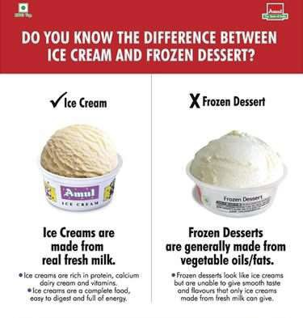

The same is not true for Frozen Desserts.

Satellite Dairies

Among satellite dairies we achieved considerable growth in Kolkata market which is very

encouraging. At Kolkata on an average we sold 5.30 lakh litre milk daily besides Ice-Cream, Flavoured Milk and Curd. Though we have retained a major share of Kolkata market, efforts are to further increase the sales volume in the same Manner.

At Pune and its surrounding markets we are selling packed Milk, Butter Milk and Curd.

Despite tough competition; I am happy to note that we have been able to improve our market   
share.

I am glad to inform you that at Mumbai we have started milk packing from our own most   
modern automated plant operating with Robot system which is the first ever such effort in   
India. The present capacity of this plant is 10 lakh litres per day (LLPD) which can be   
expanded to 20 LLPD. We have started manufacturing of Ice-cream also at this plant.

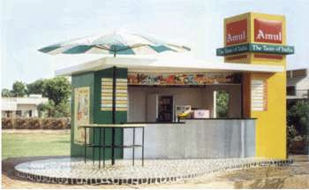

AMUL PALOURS

Amul "Utterly Delicious" Parlours

Amul has recently entered into direct retailing through "Amul Utterly Delicious" parlours created in major cities Ahmedabad, Bangalore, Baroda, Delhi, Mumbai, Hyderabad and Surat. Amul has plans to create a large chain of such outlets to be managed by franchisees throughout the country. We have created Amul Parlours at some prominent locations in the country, which are run by the company or its wholesale dealers:

1. Delhi Metro Rail Corporation

2. The Somnath Temple

3. National Institute of Design

4. Infosys Technologies in Bangalore, Mysore & Pune

5. Wipro campus in Bangalore

6. Ahmedabad Municipal Corporation

"Amul Utterly Delicious" parlours are an excellent business opportunity for investors, shopkeepers and organizations. In order to come

closer to the customer, Amul have decided to create a model for retail outlets, which would be known as "Amul Preferred Outlets"(APO).

**AMUL ICE CREAM PROCESS MODEL**

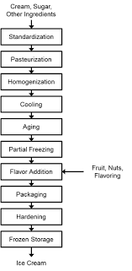

**STP (SEGMENTATION, TARGETING AND POSITIONING)**

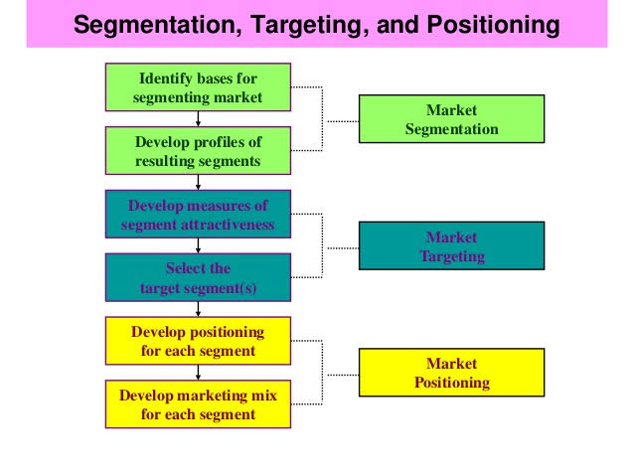

**2. AMUL MILK**

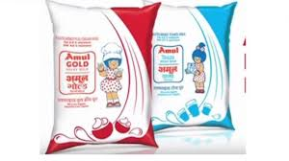

**PROCESS MODEL**

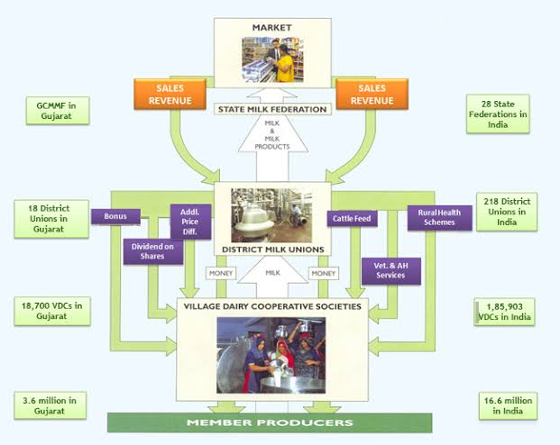

**STP**

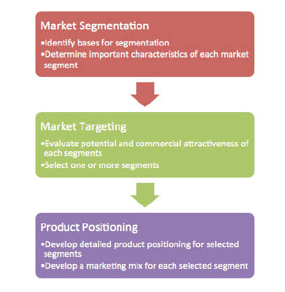

**3. AMUL FRESH CREAM**

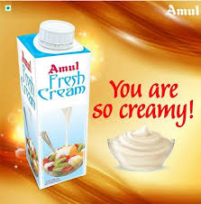

**PROCESS MODEL**

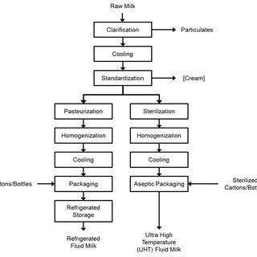

**STP**

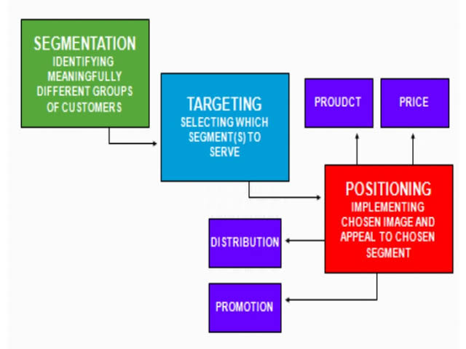

**4. AMUL FROZEN PIZZA**

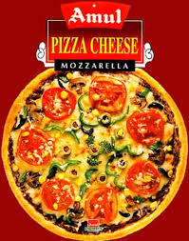 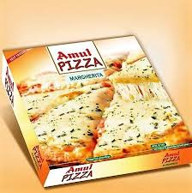

**PROCESS MODEL**

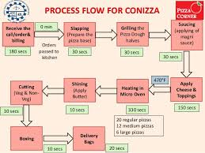

**STP**

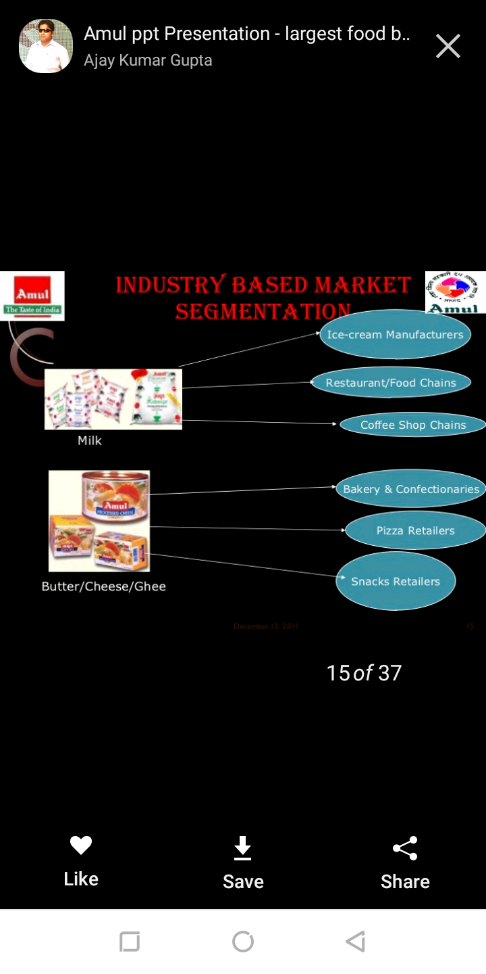

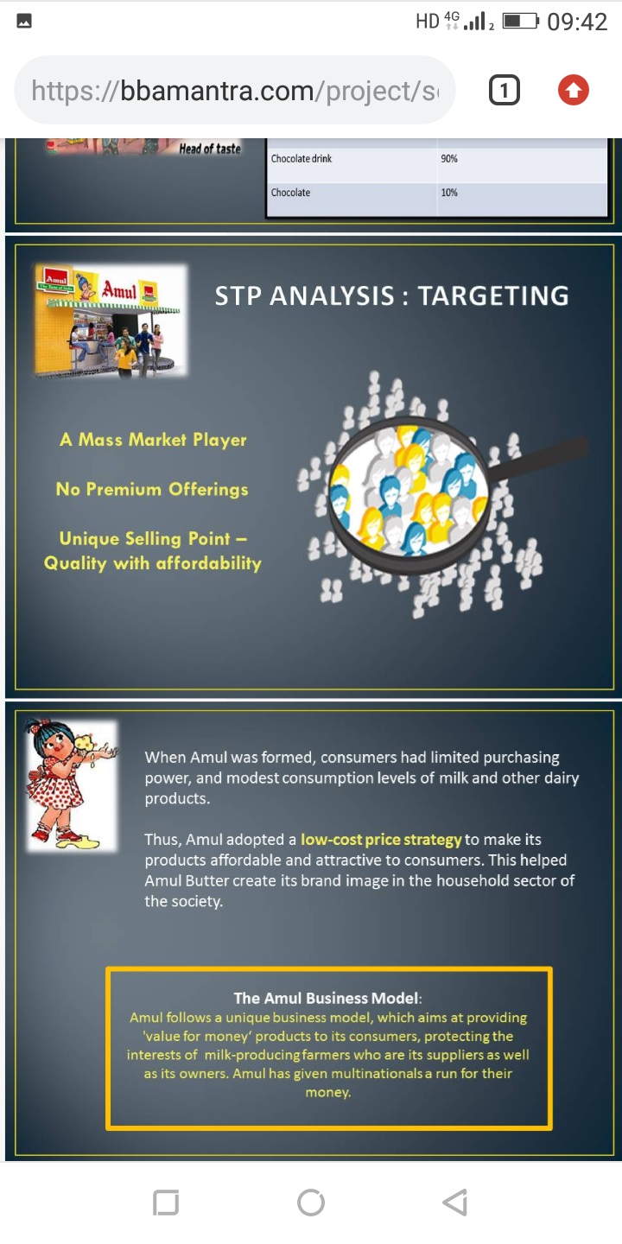

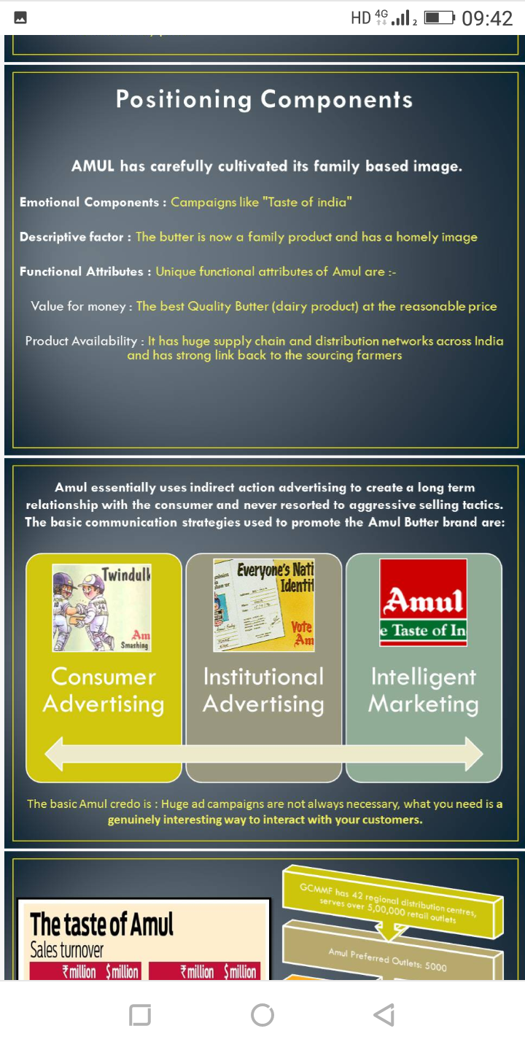

MARKETING & SALES PROMOTION STRATEGY FOR AMUL MILK, FRESH

CREAM, FROZEN PIZZA AND ICE CREAM

Looking at the current Indian marketing scenario, “AMUL” is moving back in time. An expert says that in the evolution of marketing, before the marketing concept became popular, there is a selling concept which states that "customers and businesses, if left alone will ordinarily not buy enough of the organizations products. The organization must therefore undertake an aggressive selling and promotion effort" In this present scenario, it is true that companies will survive only if there is a super efficient sales force. The reasons are that increasingly every product is being commoditized and there is an increase in the power of retails, information explosion that has given the consumer an unusual power. This has ensured that without an efficient sales force companies cannot survive.

Even when companies focus on sales effort, concept like segmentatio n should not be overlooked. For example, there has been lot of effort on increasing credit card usage in India. Credit card now comes free for life and sales people are just selling credit cards like chocolates. Is it not wise to look at whether the consumer wants a credit card? Does he like to use one? Does he have the ability to pay back? Recently a news channel showed a mutual fund agent giving discounts to a client from his brokerage. What does that mean? It simply means that we are not practicing marketing. We are just selling

Many business gurus’ are saying that,” customers are the god or king of the market”. It   
can be understood from the fact that the customer is not the king as the companies want the   
consumer to be loyal. The real fact is that no company regard customer as the king. Everyone   
in the market cares about the money. Marketing is creating and exchanging goods of value   
between company objectives are achieved in that process. So what is happening now is this   
exchange process. Marketers tried to attract customers by treating them well and thus came   
the cliche “customer is the King". It is only economics in play. It is now the choice of the   
customer that whether he wants himself to be treated as a king (and pay for it).

After realizations of the big issue Amul stated to make the marketing and sales   
promotion strategy to overcome the problem. Amul is the largest co-operative movement in   
India with 2.2 million milk producers organized in 10,552 co-operative societies in 2003-  
2004. The country's largest food company, Amul, is the market leader in butter, whole milk,   
cheese, ice cream, dairy whitener, condensed milk, saturated fats and long life milk. Amul   
follows a unique business model, which aims at providing 'value for money' p roducts to its   
consumers, while protecting the interests of the milk-producing farmers who are its suppliers   
as well as its owners. Despite being a farmers' co-operative, Amul has given multinationals a   
run for their money. In butter, cheese and saturated fats, Amul has remained the undisputed   
market leader since its inception in 1955, by offering quality products at competitive prices.   
In other categories, Amul has nullified its late mover disadvantage through aggressive   
pricing, better quality, innovative promotion, and superior distribution.

**MARKET SHARE**

The brand positions itself as a brand of both masses and classes, unlike competitors like Nestle. Gujarat Co-operative Milk Marketing Federation (GCMMF), owners of Amul brand of milk and dairy products, posted sales of Rs 11,670 crore for the year ended March 2012, almost 55% more than Nestle India’s Rs 7,541-crore sales.

Amul owns 85 percent share in butter market and 75 percent in cheese share market. It may   
be mentioned here that Amul is the market leader in Rs 600 crore cheese market in India with   
65-66% share. It also has 88% market share in butter, 63% share in infant milk and 45%   
market share in dairy whitener. Amul also enjoys a 26% share in the 25,000-crore packaged   
milk market.

With expected growth rate of 20 percent, 12% growth rate can be attributed to price rise and another 8 percent to rise in demand for dairy products.

WHAT STRATEGIES IS BEING USED BY “AMUL” TO KEEP THERE NO.1 POSITION IN THE MARKET???

AMUL PRODUCTS LIKE MILK, BUTTER, CHEESE, ICE CREAM & MANY MORE ARE MOREOVER CUSTOMER CENTRIC SINCE FROM LAST 68 YEARS.

|  |
| --- |
| Category Market Share Market Position |
| BUTTER 85% 1 |
| CHEESE 75% 1 |
| ICE CREAM 38% 1 |
| CHOCOLATE 20% 3 |
| SWEETS 50% 2 |

As shown in the above table Amul butter is one of the product which is   
holding the first position the reason behind it is as such the customers who are known as the   
king of Market has made the butter more popular, Instead of competitors of competitors like   
mother diary, nestle, Amul Butter is one of the product which is liked & tasted by almost all   
the Indian families the reason behind as such is Amul butter is most commonly used in every   
household. Amul is made from butter common salt and permitted natural colour. It is been   
marketed from last from 4 decades. Amul butter composes of fresh cream, milk fat, moisture,   
salt as well as curd in specific proportions. Low pricing strategies & trying to cater the low   
middle class people in the market.

Launching a puffed-rice centered bar Launched milk / chocolate confectionery   
Planning to enter value- added segments. Amul Chocolate made of nutritious taste & tries   
cope with all the age group. As the market share holding power is low, the company is trying   
to make some innovations regarding the taste & packaging mak ing it more tasty & attractive   
to attract more customers.

Amul Cheese is the one of the brand which is almost liked & tasted by every individuals. As such of butter the cheese made by amul is not being available in all the parts of the country, To cater large number of customers amul is all set to make an institutional market. By which the sales will be almost similar to the other products.

Amul ice cream ruling the market with the first position from many years. The reason behind this catering No.1 position is the awesome taste delightful flavours & affordable price with right quantity & quality. Due to its proper justified advertisements & packaging the amul ice cream is able to hold the No.1 position in the market.

Amul Milk handling the biggest empire of selling Milk 10 million litres per day has always been on the way of developing the rural side. To holdf there position in front of there competitors like Mahananda, Aarey, Gokul, Amul is on the urge on emphasizing on the price and develop the entire Market.

Amul Sweets standing on the second most position providing the products like Amul shrikhand (Mango, Saffron,Pistachio,Cardamom), Amul Amrakhand, Amul Mithai   
Gulabjamun, Amul Mitahi Gulabjamun Mix, Amul Mitai Kulfi Mix, Avsar Ladoos. Want to come up with some other sweet items which can attract more customers because the products they provide already exist in the market.

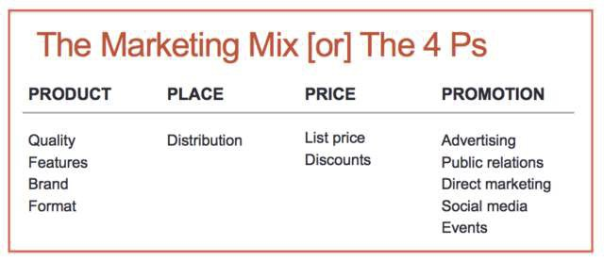

**PRODUCT MIX FOR AMUL ICE CREAM, MILK, FRESH CREAM AND FROZEN**

**PIZZA**

4PS OF AMUL COMPANY

a) PRODUCT

Tracks consumer needs & their changing lifestyles, & accordingly   
develops products to suit their needs. Product quality plays a paramount role & so   
does packaging. Amul ice cream has wide range of variety that consists of more than   
hundred flavors available in the market including 20 new flavors, which is introduced   
in summer. As ice cream is an impulsive purchase item so, its sale depends mostly on   
availability and variety.

b) PRICING

The main USP of Amul brand is its low pricing. It hits at the transnationals by reducing its prices on its product portfolio. The competitive advantage is its “backward integration” strategy, which helps substantially in cost reduction. The price of Amul ice cream is very less compared to its competitors. In novelty item the price of the flavors varies from Rs.2 to Rs22. The pricing strategy of Amul is, to target each income group of the society. The cheaper price of ice cream is meant for targeting the people with low income. Along with the low income group Amul is also targeting medium as well as the premium segment by providing different flavors at different prices.

43

c) PLACE

Any food company requires a dedicated cool chain network. Amul boasts of   
the largest cold chain network (18000 refrigerators) in India, as compared to any other   
company. It is surprising to note that it sells pizzas in rural markets too! The   
distribution of the ice cream in Delhi is done through exclusive Amul outlets situated   
in various locations. In Delhi, Amul has eleven distributors who supplies ice cream to   
more than 3000 outlets. These eleven distributors are responsible for their respective   
areas.

d) PROMOTION

Amul spends very less on its advertising budget, but spends it very   
effectively. It has the power of an umbrella brand Amul, which is highly respected   
brand name & enjoy the trust of 1000 million households. Thank to its brand mascot,   
the Amul girl, the co-operative has been able to get away with spending just one per   
cent of its revenues on advertising. In contrast, its competitors spends anywhere   
between 7 to 10 per cent on advertising. Amul positioning is “Value for Money”. It   
uses the services of Da Cunha Associates & FCB Ulka for its advertising efforts.   
Amul is a well-established brand name of GCMMF. For promotion of the ice cream   
the company gives advertisement in newspaper and magazines. It gives glow sign   
board to every retailers and also makes wall paintings on there request. Amul uses   
their punch line ---“Real milk real ice cream” for the promotion.

WHAT ARE TRIVIAL STRATEGIES???

When AMUL was formed , consumers had limited purchasing power & modest consumption levels of milk & other dairy products . thus AMUL adopted:-

Low-Cost Price strategy was adopted to make the product affordable & alluring to consumers by guaranteeing them value for money.

The main aim of Amul is to provide quality products to the consumers at minimum cost. The goal of Amul is to provide maximum profit in terms of money to the farmers.

Low cost of production of AMUL Milk production is scale insensitive and labour   
intensive. Due to low labour cost, cost of production of milk is significantly lower in AMUL.   
Moving consumers to loose milk to packaged milk and gradually move them up the value   
chain ( tetra pack to beverages )Being exposed to a brand , it is natural for a customer to use   
more products.

1. Product Positioning Strategy

2. • India’s first Pro -biotic Wellness Ice cream& sugar free delights for diabetics. 3. • Amul launches FreshPaneer “free from harmful chemicals”.   
4. • Low priced Amul Ice creams made Kwality Walls life hell.

Effective Segmentation Wide range of product categories caters to consumers across all market segments.

Eg:-Amul Kool is targeted at children, teenagers prefer Kool Café as it has a cool imagery associated with it. Segmentation is not as easy as in Curd and low fat products due to mixed audiences. Eg:- Ghee , Butter & Cheese In India, the most used spread is Ghee, than butter , cheese , low fat butter , margarin, cheese spread & mozzarella cheese.

Changing the Retail Environment Striking out on its own with AMUL outlets or parlours to   
deliver consumers total brand experience. Product Repositioning Amul marketed bottled   
water named “Jaldhara”due to its less potential in the market and launched “ Narmada Neer”

ADVERTISEMENT DONE BY “AMUL” TO PROMOTE THERE BRAND

In 1966, Amul hired [Sylvester daCunha,](http://en.wikipedia.org/w/index.php?title=Sylvester_daCunha&action=edit&redlink=1) then managing director of the   
advertising agency AS to design an ad campaign for Amul Butter. daCunha designed a   
campaign as series of hoardings with topical ads, relating to day-to-day issues.It was popular   
and earned a Guinness world record for the longest running ad campaign in the world. In the   
1980s, cartoon artist [K umar Morey](http://en.wikipedia.org/w/index.php?title=Kumar_Morey&action=edit&redlink=1) and script writer [Bharat Dabholkar](http://en.wikipedia.org/w/index.php?title=Bharat_Dabholkar&action=edit&redlink=1) had been involved   
with sketching the Amul ads; the latter rejected the trend of using celebrities in advertisement   
campaigns. Dabholkar credited chairman Verghese Kurien with creating a free atmosphere   
that fostered the development of the ads.

Despite encountering political pressure on several occasions, daCunha's agency has made it a policy of not backing down. Some of the more controversial Amul ads include one commenting on the Naxalite uprising in West Bengal, on the Indian Airlines employees strike, and one depicting the Amul butter girl wearing a Gandhi cap.

Its advertising has also started using tongue- in-cheek sketches starring the Amul baby commenting jovially on the latest news or current events. The pun in her words has been popular. The Amul ads are one of the longest running ads based on a theme, now vying for the Guinness records for being the longest running ad campaign ever.

Since 1967 Amul products' mascot has been the very recognizable "Amul baby" (a chubby butter girl usually dressed in polka dotted dress) showing up on hoardings and product wrappers with the equally recognizable tagline Utterly Butterly Delicious Amul. The mascot was first used for Amul butter. But in recent years in a second wave of ad campaign for Amul products, she has also been for other product like ghee and milk. She is probably one of the most enduring mascots in the world.

Amul being a perfect in Promoting there Products through various Campaigns, uplifting some or the other social issues, Issues which can create an awareness among the people about a particular topic is being picked up by ‘AMUL’.

For them promoting there brand is little more easy through media as such like being the Main Sponsors & Associate Sponsors for various Reality Shows & Programs.

CONCLUSION

GCMMF that owns Amul , Asia’s largest milk brand realized that with the changing lifestyle   
& increased awareness about health issues , there has been a discernable shift towards health   
based drinks from carbonated drinks. To utilize the potential of flavoured milk, butter milk &   
other milk based beverages that have an age old tradition in India. By identifying the   
targeted teenagers & youth , who were biggest consumers of colas & aerated drinks. The   
New variants of the brand were advertised through major national channels with special focus   
on youth oriented TV channels like MTV & Cartoon Network . By identifying the trend &   
introducing variants , Amul has been emerged as the fastest growing brand in non-carbonated   
soft drinks category. Compared to the distribution network of other brand of beverages to the   
Amul, it has to improve their network properly and make product available to the customer   
and also handle the customer problem if any. Company has to maintain a good relationship   
with the retailers by giving better margin, schemes/discounts.

Amul plans to be a leader in food business. This 3458 crore co-operative is planning to enter in restaurants, ready-to-eat curries etc. it also plans to launch ready to drink coffee and tea. The plan of this co-operative is to make Amul, India’s best known food brand and also to garner a sizable marketplace in 30 countries wherein its products are exported to. The brand should not be known in milk, butter & cheese but as a food brand. Its numerical target, a turnover in excess of Rs. 10000 crore by 2018.

In words of Dr, verghese Kurien, chairman (GCMMF). Amul is a brand that is trustworthy of 1000 million Indians. Why should it be seen only as a brand label for butter? Hope, its competitors are listening!

WIBILOGRAPHY

➢ [www.amul.com](http://www.amul.com/)

➢ [www.indiadairy.com](http://www.indiadairy.com/)

➢ [http://marketingpractice.blogspot.com](http://marketingpractice.blogspot.com/)

➢ [http://www.fmcgmarketers.blogspot.com](http://www.fmcgmarketers.blogspot.com/)   
➢ [http://www.indianfoodindustry.net](http://www.indianfoodindustry.net/)   
➢ [www.ibef.org](http://www.ibef.org/)